

**Placement Empowerment Program**

***Cloud Computing and DevOps Centre***

Write the Shell Script to Monitor Logs : Create a script that monitors server logs for errors and alert you

Name: MADHUMETHRA AP Department : IT



**Introduction**

Log files play a critical role in IT systems, as they record activities and events generated by applications, servers, and network devices. Monitoring these logs helps identify issues such as errors, warnings, and suspicious activities that may require immediate attention. Automating the monitoring process ensures efficiency and reduces the risk of missing critical information. This PoC demonstrates the creation of a PowerShell script to monitor logs in real-time. The script will detect specific keywords (like "error") in a log file and alert the user when such events occur

**Overview**

we will explore AWS S3 (Simple Storage Service) to understand its functionality as a reliable cloud storage solution. The task involves creating an S3 bucket, uploading and downloading files, and configuring access permissions to manage who can access the stored data. This PoC demonstrates S3's versatility in securely storing and retrieving files, both publicly and privately. We will also set bucket policies to control access and test public URLs for hosted files. By completing this task, we gain hands-on experience with S3 and its key features, such as scalability, security, and cost-efficiency.

**Objective**

The goal of this project is to:

1. Understand AWS S3 Basics: Learn how to create, configure, and manage an S3 bucket for cloud storage.
2. File Operations: Gain hands-on experience in uploading, downloading, and managing files within the S3 bucket.
3. Access Control: Configure bucket policies and permissions to manage secure and public access to stored data.

**Importance of Storage Bucket(S3)**

**Foundation for Advanced Use Cases**: Learning how to handle S3 storage is a stepping stone for mastering cloud computing and deploying large-scale applications.

**Hands-On Learning of Cloud Storage**: AWS S3 provides a practical platform to learn cloud storage concepts, enabling users to create buckets, upload/download files, and manage data at scale.

**Data Security and Access Control**: By configuring bucket policies and permissions, users can secure their data and manage who can access it.

**Step-by-Step Overview**

Step1:

Create a Folder called logs for Your Logs and Script

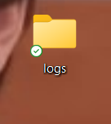

Step2:

Open Notepad and Add the following sample text to it and Save the file as mylogfile.log inside the logs folder

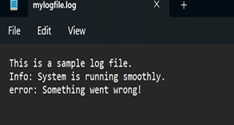

Step3:

Open Notepad and Type the following PowerShell script into it and Set the $LogFilePath address to the mylogfile.log which you saved in logs folder. Save the file as monitor_logs.ps1 inside the same logs

Step4:

Click the Windows Key and Search for Windows PowerShell and click Run as Administrator

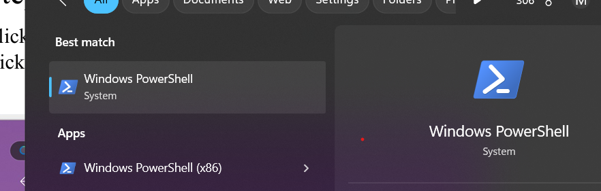

Step 5:

Run the following command to allow script execution: Set-ExecutionPolicy-Scope CurrentUser-ExecutionPolicy RemoteSigned When prompted, type Y and press EnterRun the following command to allow script execution:Set-ExecutionPolicy-Scope CurrentUser-ExecutionPolicy RemoteSigned When prompted, type Y and press Enter

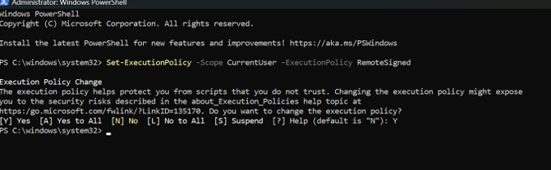

Step 6:

Navigate to the logs folder

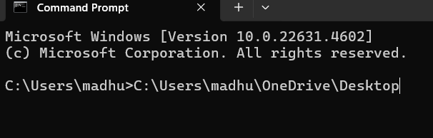

Step 7:

Run the script: .\monitor_logs.ps1

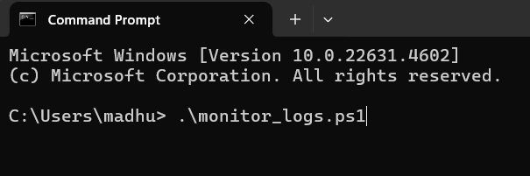

Step 8:

Open mylogfile.log in Notepad and Add a new line with the word "error" and Save the file

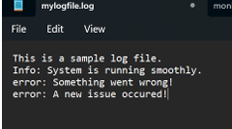

Step 9:

Check PowerShell — you should seean alert like: ALERT:Keyword'error' found in log: error: A new issue occurred

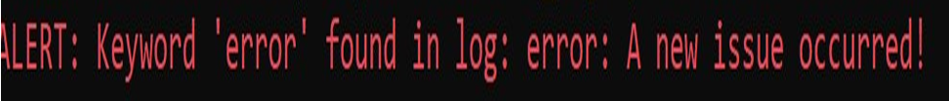

**Output**

# Bycompleting this Proof of Concept (PoC), we will:

# 1. Successfully create and execute a PowerShell script to monitor log files in real time.

# 2. Detect and alert on predefined keywords (e.g., "error") to highlight critical events.

# 3. Gain hands-on experience with PowerShell scripting and automation on a Windows system.

# 4. Understand the importance of log monitoring in proactive system maintenance and troubleshooting.

# 5. Learn to customize and scale the script for more advanced monitoring scenarios in future projects